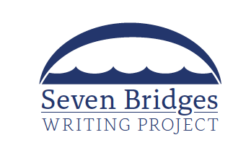
The National Writing Project at the University of North Florida

SUMMER INSTITUTE APPLICATION

The Summer Institute is open to K-12 public school teachers as well as to school and district-level administrators (space permitting). Participants are expected to commit to being present for each of the five days of the Institute (June 20-24, 2022). There is no cost to participate in the Institute and all materials will be provided by the Seven Bridges Writing Project. Select participants will be invited to become “teacher consultants” for the Project.

Please complete this application in its entirety and submit it to Dr. John Wesley White, Director, Seven Bridges Writing Project (j.white@unf.edu). Space is limited.
Name
Email Address
Mailing Address
Phone Number
Current Position
Past Teaching Positions (if any)

Please Describe what you hope to gain from being a participant in the Summer Institute.

Teacher consultants will be the lead district liaisons between our National Writing Project site and schools. Working in concert with our UNF faculty, they will conduct writing professional development in schools, participate in research projects, and they will travel with us to the annual meeting of the National Council of Teachers of English.

